THE KINGDOMS OF ETERNAL SPLENDOUR
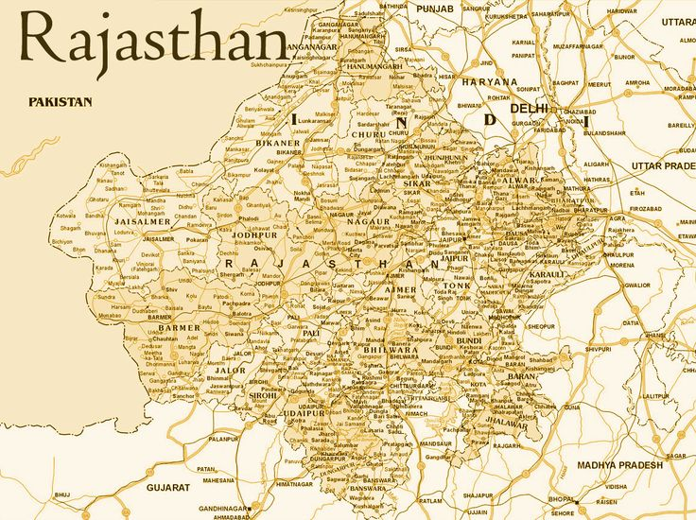

ITINERARY PUBLISHED:
15 MAR’27 | DAY 01 | ARRIVE DELHI
Meeting and assistance upon arrival at Delhi International Airport transfer to hotel in Delhi. Upon arrival check in at hotel in Delhi.

Delhi – Where Centuries of History Meet the Pulse of Modern India: Few capital cities in the world possess a history as rich, captivating, and enduring as Delhi, the timeless capital of India. For over a millennium, this legendary city has stood at the crossroads of empires, drawing successive dynasties—including the Mongols, Turks, Persians, Afghans, Mughals, and the British—each leaving behind an extraordinary architectural, cultural, and historical legacy that continues to define the city's unique character.

Dinner & overnight stay at hotel in Delhi
16 MAR’27 | DAY 02 | DELHI
Morning after breakfast proceed for Delhi Sightseeing – A Journey Through the Capital’s Heritage
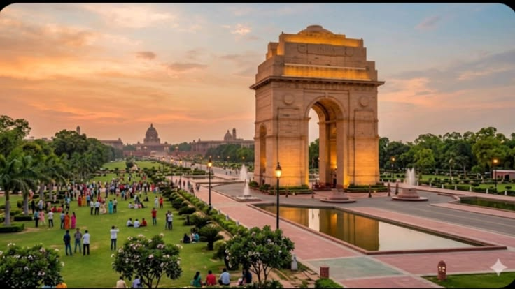
Explore the contrasting character of New Delhi and Old Delhi, where grand colonial architecture, magnificent monuments, vibrant bazaars, and centuries of history come together to reveal the many facets of India’s capital. Begin your exploration of New Delhi, distinguished by its elegant British colonial architecture, broad tree-lined avenues, landscaped boulevards, and stately government buildings. Visit the Laxminarayan Temple (Birla Mandir), a beautifully designed modern Hindu temple known for its graceful architecture and spiritual ambience. Continue to India Gate, the imposing 42-metre-high war memorial arch that stands as one of the most recognisable landmarks of the capital. Drive past the magnificent Parliament House and the Secretariat buildings, followed by the impressive Rashtrapati Bhavan, the official residence of the President of India. Together, these monumental structures reflect the architectural grandeur and historic evolution of New Delhi. Continue to Qutub Minar, one of Delhi’s most celebrated monuments and a UNESCO World Heritage Site. Rising majestically against the Delhi skyline, this remarkable medieval tower is adorned with intricate carvings and inscriptions, standing as a magnificent testament to the architectural and cultural heritage of the period.

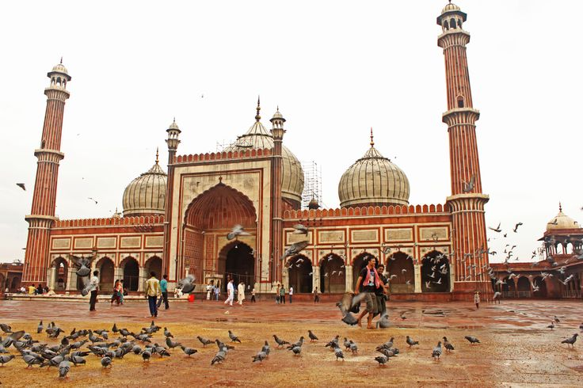
The experience then takes you into the vibrant heart of Old Delhi, beginning with a visit to the historic Jama Masjid, commissioned in the 17th century by Mughal Emperor Shah Jahan. Its impressive courtyards, soaring minarets, and red sandstone and marble architecture make it one of the finest examples of Mughal religious architecture in the city. Continue to Chandni Chowk, the historic commercial heart of Old Delhi, where narrow lanes, colourful markets, traditional shops, street-food stalls, and the lively rhythm of everyday life create an unmistakably authentic Delhi experience. A drive past the magnificent Red Fort, with a brief photo stop, offers a glimpse of another great symbol of the Mughal era. Conclude the sightseeing at Raj Ghat, the serene memorial marking the cremation site of Mahatma Gandhi. Set amidst peaceful landscaped gardens, it provides a quiet and reflective conclusion to a day spent discovering Delhi’s remarkable history and heritage

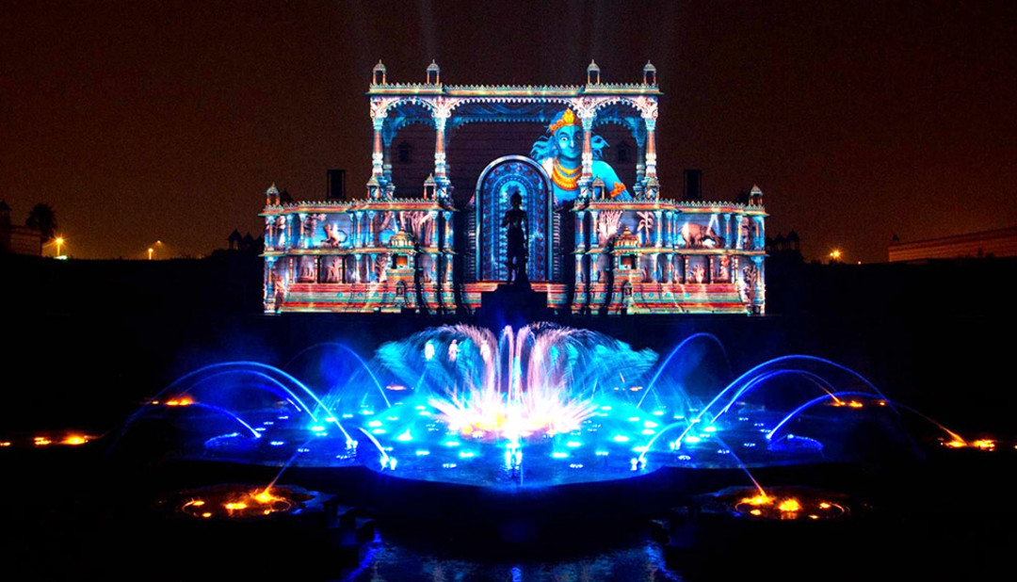
Afternoon proceed for an astonishing and beautiful fountain show at Akshardha Temple
As twilight descends, visitors are invited to take their seats within the magnificent step-well amphitheatre of Swaminarayan Akshardham Temple and immerse themselves in an experience that transcends time and reality. The Sahaj Anand Water Show unfolds as a profound journey into eternal truths, where storytelling, spirituality, and cutting-edge technology converge in perfect harmony. Set within the grand Yagnapurush Kund—a stunning replica of traditional Indian step-wells spanning. At its focal point lies a sacred nine-lotus design, inspired by ritual yantras used in Hindu ceremonies, symbolizing cosmic harmony. Presiding over this majestic space is the 27-foot-tall bronze murti of Neelkanth Varni, whose serene presence evokes inspiration, devotion, and inner strength. The 24-minute presentation is a breathtaking orchestration of multi-sensory elements, seamlessly blending multi-colour lasers, high-definition projections, dynamic water jets, underwater flames, surround sound, and live performances. Together, they bring to life a timeless narrative drawn from the ancient Kena Upanishad, one of the most revered texts of Vedic wisdom. The story unfolds with the playful innocence of children by a tranquil lake, whose joy and creativity give rise to a delicate flower formed from water. However, their lighthearted celebration inadvertently disturbs the devas—the powerful gods of the elements—who are reveling in their triumph over evil. What follows is a compelling interplay between humility and pride, innocence and power, as the fragile beauty of the children’s creation stands threatened by divine wrath. This extraordinary presentation, crafted through the collaboration of international experts alongside dedicated BAPS volunteers and sadhus, is far more than a visual spectacle. It is a deeply moving spiritual experience that resonates with audiences of all ages, leaving them inspired, introspective, and enriched.

Dinner & overnight stay at hotel in Delhi

17 MAR’27 | DAY 03: | DELHI – VARANASI (6E 2361 – 12:55HRS / 14:20HRS)
Morning after breakfast proceed to airport to board flight for Varanasi. Meeting and assistance upon arrival at Varanasi airport and transfer to hotel in Varanasi.

Varanasi – The Eternal City on the Sacred Ganges: Varanasi, also known as Benares or Kashi, is one of India’s most spiritually evocative cities and one of Hinduism’s seven sacred cities. Set gracefully along the banks of the holy River Ganges, Varanasi is a place where faith, tradition, ritual, and everyday life have intertwined for centuries. It is a city that cannot truly be captured in words—it is best experienced through its atmosphere, sounds, colours, and timeless rituals. With more than a hundred historic ghats lining the Ganges, each carrying its own character and significance, the riverfront forms the spiritual heart of the city. At dawn, the ghats come alive as pilgrims gather for prayers and rituals, while boats glide quietly across the river, offering an unforgettable perspective of the ancient city awakening with the first light of day.

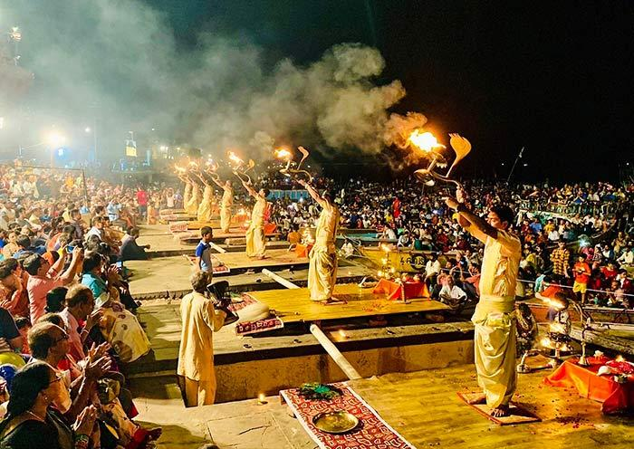
Evening witness Ganga Aarti – A Sacred Celebration of Life and Devotion: The Ganga Aarti is far more than a traditional religious ceremony; it is a deeply moving communal experience through which devotees express reverence, gratitude, and devotion to the sacred River Ganges. As evening descends upon the ghats of Varanasi, the riverfront comes alive with the glow of ceremonial lamps, devotional chants, incense, and the rhythmic sound of bells, creating an atmosphere that is both vibrant and profoundly spiritual. One of the most beautiful moments comes when devotees and visitors release small floating lamps, or diyas, onto the river. Each glowing lamp carries a personal prayer, heartfelt wish, or expression of gratitude, gently drifting across the waters and transforming the Ganges into a shimmering stream of light. The simple act creates a powerful connection between the individual, the sacred river, and the timeless traditions of Hindu spirituality.

Dinner & overnight stay at hotel in Varanasi

18 MAR’27 | DAY 04: | VARANASI
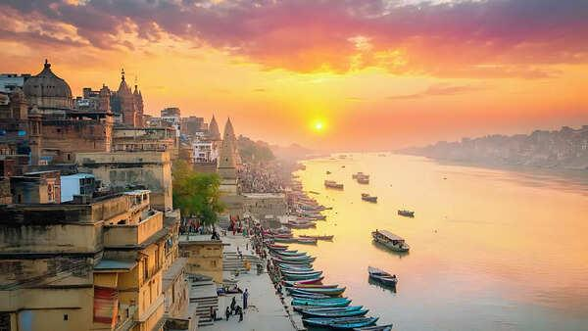
Sunrise Boat Ride on the Ganges & Visit to Vishwanath Temple: Begin the day with an early morning boat ride on the sacred River Ganges, one of the most evocative experiences in Varanasi. As the first rays of sunlight gently illuminate the riverfront, the ancient ghats gradually awaken, revealing a timeless panorama of spirituality, devotion, and daily life. From the tranquil waters, witness pilgrims gathering along the ghats to bathe in the holy river, offer prayers, and perform traditional rituals. The sight of devotees carrying out centuries-old practices against the backdrop of Varanasi’s historic riverfront offers a deeply atmospheric glimpse into the spiritual traditions that continue to shape the city. As the sun rises above the horizon, the changing light casts a golden glow across the river and the centuries-old architecture lining its banks. Seen from a boat, this peaceful moment creates a quietly uplifting and contemplative experience, allowing visitors to appreciate Varanasi from an entirely different perspective. The boat journey also offers views of the city’s cremation ghats, where ancient Hindu funeral traditions continue to be observed. These sacred spaces provide a profound insight into the Hindu understanding of life, death, and the eternal cycle of existence. Visitors are encouraged to observe respectfully and discreetly. Later, visit the revered Shri Kashi Vishwanath Temple, one of the most sacred temples dedicated to Lord Shiva. Often referred to as the Golden Temple because of its distinctive gold-plated towers, the temple holds immense spiritual significance for Hindu devotees.

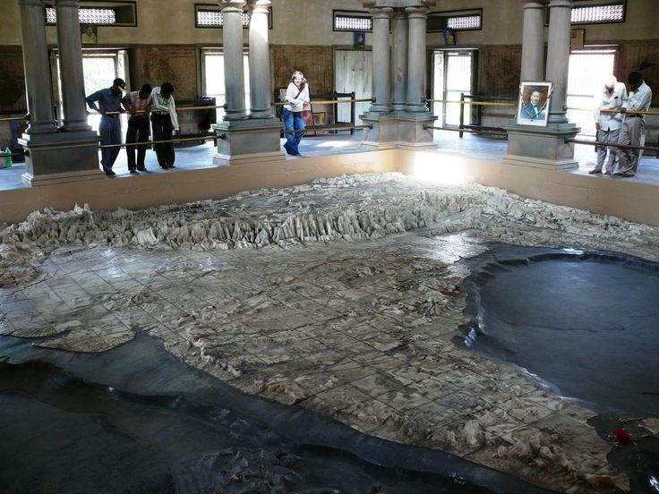
Return back to hotel for freshen up, have your breakfast and get ready for Varanasi Heritage & Temple Tour: Discover another fascinating facet of Varanasi on a half-day exploration through its spiritual heritage, religious traditions, architecture, and intellectual legacy. Beyond the sacred ghats of the Ganges, this experience introduces visitors to a remarkable collection of temples and cultural landmarks that reflect the city’s enduring importance as a centre of faith and learning. Begin with a visit to the Bharat Mata Temple, a unique temple dedicated not to a traditional deity but to the spirit of India itself. Its principal attraction is an impressive three-dimensional marble relief map of India, offering a distinctive representation of the country’s geographical landscape and making the temple a fascinating cultural experience. Continue to the Durga Temple, an elegant shrine dedicated to Goddess Durga and distinguished by its striking red-coloured architecture. The visit is followed by the Tulsi Manas Temple, a modern marble temple associated with the revered poet-saint Goswami Tulsidas. Its walls are beautifully inscribed with verses and scenes from the Ramcharitmanas, the celebrated Hindi rendition of the Ramayana, bringing the epic’s timeless teachings to life through art and literature. The tour continues to the New Vishwanath Temple, situated within the grounds of Banaras Hindu University and known for its impressive height and distinctive architecture. The temple is dedicated to Lord Shiva and is an important spiritual landmark of the university campus. Non-Hindus are not permitted inside the temple. Drive through the expansive campus of Banaras Hindu University (BHU), one of India’s most renowned centres of education and learning, and visit its museum, which offers further insight into the artistic and cultural heritage of the region. Conclude the tour with a view of the Alamgir Mosque, traditionally associated with the Mughal Emperor Aurangzeb. Perched above the Ganges, the mosque presents an intriguing architectural contrast and adds another historical layer to Varanasi’s extraordinarily diverse cultural landscape.
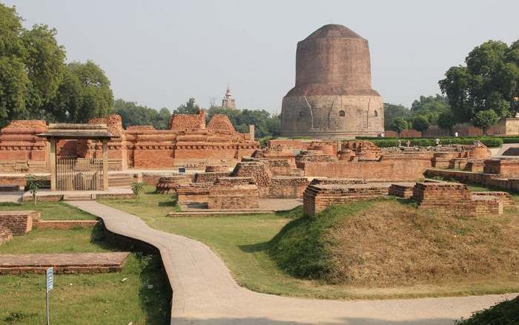
Afternoon explore Sarnath, one of the most revered Buddhist pilgrimage sites in India and a place of profound historical and spiritual significance. Located just outside Varanasi, Sarnath is traditionally regarded as the site where Gautama Buddha delivered his first sermon after attaining enlightenment, setting in motion the teachings that would become the foundation of Buddhism. The visit begins with the archaeological ruins, dominated by the magnificent Dhamek Stupa, an imposing structure believed to mark the spot where Buddha delivered his first sermon to his five disciples. Rising prominently from the surrounding ruins, the stupa stands as a powerful symbol of Buddhism and attracts pilgrims and visitors from across the world. Continue through the remains of the ancient monasteries and temples, which offer a fascinating glimpse into Sarnath’s past as an important centre of Buddhist learning and spiritual practice. Among the archaeological treasures is the remains of the Ashoka Pillar, erected during the reign of Emperor Ashoka and originally rising more than 20 metres. Its celebrated Lion Capital, now preserved in the Sarnath Museum, has become one of the most recognisable symbols of India and forms the inspiration for the country’s national emblem. A visit to the Sarnath Museum provides an opportunity to admire the remarkable collection of sculptures, archaeological discoveries, and artefacts unearthed from the surrounding site. Among its most prized exhibits is the exquisitely carved Lion Capital of Ashoka, renowned for its artistic refinement and historical significance.

Dinner & overnight stay at hotel in Varanasi

19 MAR’27 | DAY 05: | VARANASI – KHAJURAHO (VANDE BHARAT EXPRESSS – 05:15Hrs / 13:10Hrs)
On time transfer to Varanasi station to board train for Khajuraho. Meeting and assistance upon arrival at Khajuraho station and transfer to hotel. Upon arrival check in at hotel in Khajuraho.

Khajuraho – A Masterpiece of Art, Architecture & Human Expression: The magnificent temples of Khajuraho, built under the patronage of the Chandela dynasty between the 10th and 11th centuries, stand among India’s most extraordinary expressions of medieval architecture, sculpture, and artistic imagination. Once part of a much larger temple complex, the surviving group of temples today offers a remarkable window into the cultural, spiritual, and artistic sophistication of Central India during the Chandela period. Adorned with an astonishing array of finely sculpted figures and intricate ornamental details, the temples portray the many dimensions of human existence—from devotion, music, dance, and everyday life to love and sensuality. The celebrated erotic sculptures, found among the wider repertoire of carvings, have attracted considerable attention and interpretation since the temples were brought to wider international notice following their rediscovery by British officer T. S. Burt in 1838.

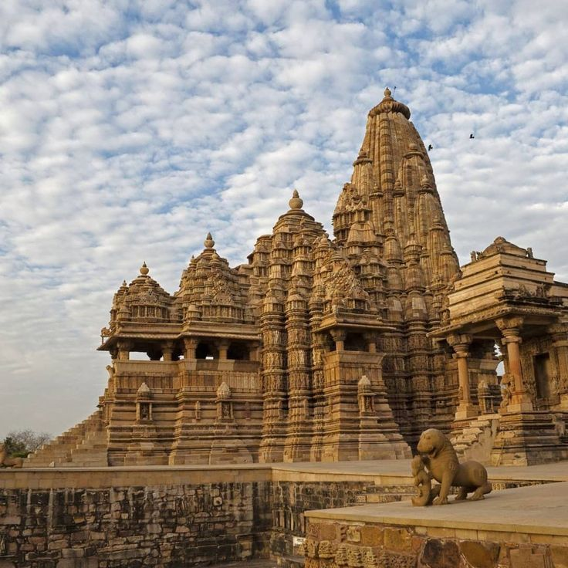
Afternoon proceed for tour of Khajuraho – A Journey Through Sacred Art & Architectural Splendour: Embark on a fascinating half-day exploration of the Western and Eastern Groups of Temples at Khajuraho, an extraordinary ensemble celebrated for its magnificent architecture, intricate stone carvings and remarkable artistic expression. Begin with the Western Group of Temples, the most celebrated collection at Khajuraho. The highlight is the magnificent Kandariya Mahadev Temple, rising nearly 32 metres and adorned with an astonishing profusion of finely carved sculptures. Its walls and facades portray an extraordinary range of subjects, from divine figures, musicians and celestial beings to scenes depicting love, beauty and sensuality, reflecting the sophisticated artistic vision of the Chandela period. Continue to the Chaunsat Yogini Temple, one of the oldest surviving shrines at Khajuraho and notable for its distinctive granite construction. The Devi Jagadambi Temple, dedicated to the Mother Goddess, is admired for its graceful proportions and exquisite sculptural details. The Chitragupta Temple, dedicated to Surya, the Sun God, is particularly distinguished by its impressive image of the deity and beautifully sculpted exterior. Together, these temples offer a captivating glimpse into the religious beliefs, artistic traditions and cultural sophistication of medieval India. Continue to the Eastern Group of Temples, where Hindu and Jain traditions exist harmoniously within the same sacred landscape. The magnificent Parsvanath Temple, the largest and finest of the Jain shrines, is renowned for its elegant architecture and exceptionally detailed carvings. Also visit the Adinatha Temple, dedicated to the first Jain Tirthankara, as well as the beautifully ornamented Ghantai Temple and the Vamana Temple, dedicated to Lord Vishnu in his Vamana incarnation. A visit to Khajuraho is far more than an architectural excursion; it is an encounter with a remarkable chapter of Indian history where faith, craftsmanship, mythology and human expression were transformed into enduring works of art carved in stone

Dinner & overnight stay at hotel in Khajuraho

20 MAR’27 | DAY 06: | KHAJURAHO – ORCHHA (173Kms, 02Hrs drive)
Morning after breakfast drove to Orchha. Upon arrival check in at hotel in Orchha.

Orchha – A Timeless Legacy of the Bundelas: Located approximately 26 km from Jhansi, Orchha is a captivating medieval town founded in 1531 by the Bundela rulers on the serene banks of the Betwa River. Remarkably untouched by the passage of time, Orchha preserves an exceptional collection of magnificent palaces, temples and monuments dating primarily from the 16th and 17th centuries, offering a fascinating glimpse into the grandeur and heritage of medieval India. The town is perhaps best experienced through its impressive fort-palace complex, where imposing stone walls enclose a remarkable world of courtyards, gardens, gateways, pavilions and temples. Rising above the complex are elegant chhatris (cenotaphs) and richly ornamented battlements, creating an enchanting silhouette against the surrounding landscape. The harmonious blend of Rajput architectural traditions, Mughal influences and intricate artistic detailing gives Orchha a distinctive character found nowhere else.
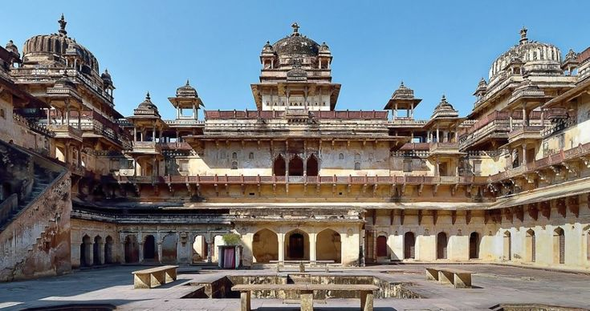
Afternoon proceed for sightseeing tour of Orchha – Palaces, Temples & Living Heritage: Explore the magnificent architectural treasures of Orchha, beginning with the Jahangir Mahal, an imposing palace built as a harmonious synthesis of Hindu and Islamic architectural traditions. Its grand courtyards, elegant domes, ornate balconies and finely crafted details reflect the cultural exchange and artistic refinement of the Bundela era. Continue to the Raj Mahal, one of Orchha's oldest royal residences, renowned for its beautifully preserved murals depicting scenes from Hindu mythology, royal life and religious traditions. The intricate paintings offer a fascinating insight into the artistic heritage and devotional spirit of the Bundela court. Visit the revered Ram Raja Temple, a unique palace-turned-temple and one of Orchha's most distinctive landmarks. Here, Lord Rama is worshipped as a king, giving the temple an extraordinary character that blends royal traditions with deep religious devotion. Admire the imposing Chaturbhuj Temple, an architectural masterpiece originally conceived for Lord Rama and later associated with Lord Vishnu. Its distinctive cruciform plan, soaring structure and monumental proportions make it one of Orchha's most impressive landmarks. Conclude with a visit to the Lakshminarayan Temple, dedicated to Goddess Lakshmi and particularly admired for its remarkable murals. The temple beautifully combines the architectural character of a temple with the defensive elements of a fort, while its well-preserved paintings add an exceptional artistic dimension to the experience.

Dinner & overnight stay at hotel in Orchha

21 MAR’27 | DAY 07: | ORCHHA – JHANSI (17Kms, 43Mnts drive) – AGRA CANTT (VANDE BHARAT EXPRESS
– 08:43Hrs /11:01Hrs)
On time transfer to Jhansi station to board train for Agra. Meeting and assistance upon arrival and transfer to hotel in Agra. Upon arrival check in at hotel in Agra.

Agra – Where History, Legend & Imperial Grandeur Converge: Situated gracefully on the banks of the Yamuna River, Agra is a city where centuries of history, legend and imperial splendour come together. Tradition attributes the foundation of the present city to Raja Badal Singh around 1475 AD, although references to Agraban in the Mahabharata suggest that the region has enjoyed significance since ancient times and was closely associated with Mathura, one of the oldest sacred cities of northern India. Agra rose to greater prominence during the rule of the Lodi dynasty, when Sikandar Lodi established it as his capital in the late 15th century, laying the foundations for its emergence as an important political and cultural centre of North India.

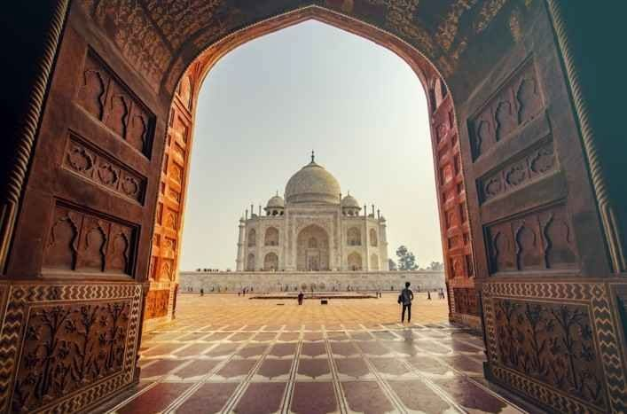
Afternoon proceed for sightseeing tour of Agra visiting The Taj Mahal – A Monument to Eternal Love: Following the death of his beloved wife Mumtaz Mahal in 1631, the Mughal emperor Shah Jahan, renowned for his passion for architecture and the arts, resolved to create a memorial of unparalleled beauty — a monument that would transcend time and remain forever etched in the memory of the world. The site was chosen with extraordinary thought. Set upon a bend of the Yamuna River, the location allowed the monument to be admired from Shah Jahan's royal quarters within Agra Fort, further upstream, creating a magnificent visual connection between the emperor's palace and the mausoleum. Construction of the Taj Mahal began in 1631, bringing together master architects, craftsmen, stonecutters, calligraphers, inlay artists and artisans from across the Mughal Empire and beyond. Over the course of approximately 22 years, thousands of skilled craftsmen worked to bring Shah Jahan's vision to life, creating one of the world's most celebrated masterpieces. Built predominantly in gleaming white marble, the Taj Mahal is a remarkable study in contrasts — monumental in scale yet extraordinarily delicate in detail, majestic in its overall conception yet refined in every carved and inlaid surface. Its perfectly balanced proportions, graceful domes, elegant minarets, intricate floral motifs and exquisite pietra dura work demonstrate an exceptional level of craftsmanship. More than an architectural masterpiece, the Taj Mahal has endured as a timeless symbol of love, remembrance and devotion. As changing light transforms its marble façade from soft pinks and golden hues to luminous white and silver, the monument reveals a different character throughout the day — making every encounter with the Taj Mahal feel uniquely memorable.

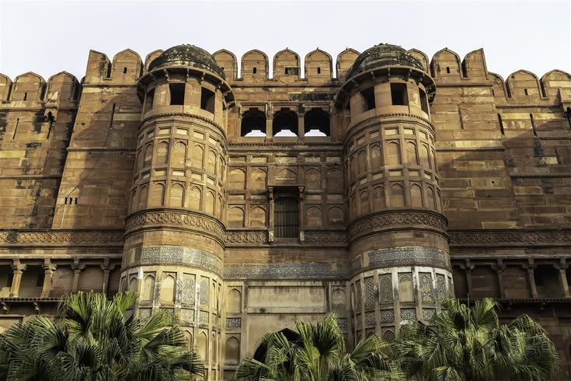
Agra Fort – A Citadel of Mughal Power & Grandeur: Begin your exploration of Agra's imperial heritage with the magnificent Agra Fort, whose construction was initiated by Emperor Akbar in 1565. Built primarily of imposing red sandstone, this vast fortified complex stretches for approximately 2½ kilometres, its formidable walls once protected by a broad moat and imposing gateways. Far more than a military stronghold, Agra Fort evolved into a magnificent city within a city, serving as a royal residence, administrative centre and seat of Mughal power. Within its massive walls lies an extraordinary collection of palaces, audience halls, mosques, gardens and architectural masterpieces, reflecting the changing tastes and ambitions of successive Mughal emperors. Among its principal highlights is the elegant Moti Masjid, or Pearl Mosque, admired for its serene white-marble architecture. The Diwan-i-Am, or Hall of Public Audiences, was where the emperor received his subjects and addressed matters of state, while the more intimate Diwan-i-Khas, or Hall of Private Audiences, was reserved for distinguished guests, nobles and important affairs of the empire. Also discover the Octagonal Tower, offering memorable views towards the Yamuna and the Taj Mahal, and Jahangir's Palace, one of the finest surviving residential structures within the fort, showcasing a harmonious blend of Hindu and Islamic architectural influences. Every courtyard, pavilion and intricately decorated chamber reveals another chapter of Mughal history, from Akbar's military vision to the architectural refinement of Shah Jahan's reign.

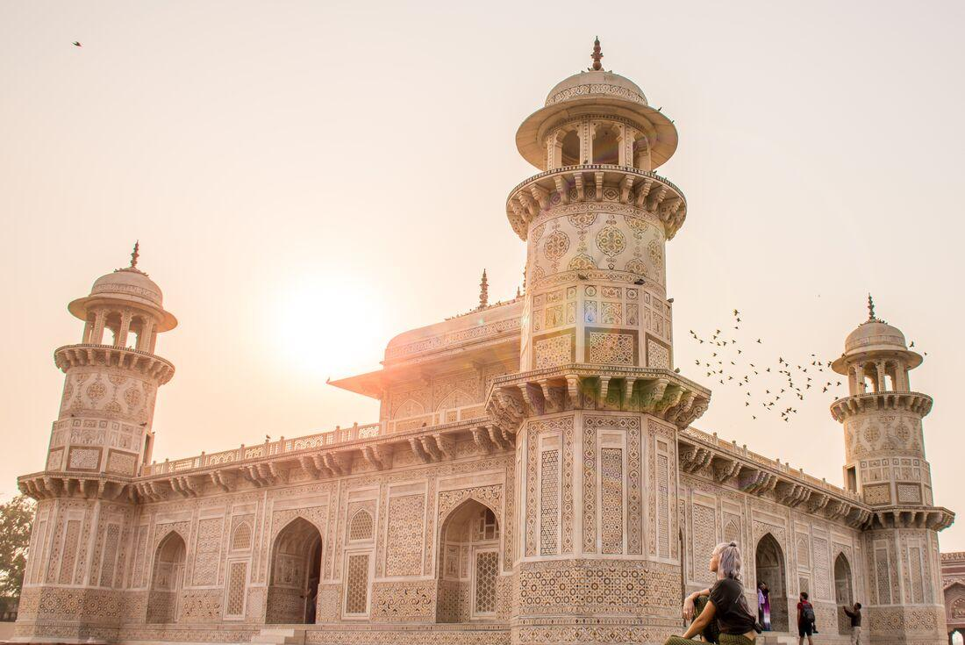
Itmad-ud-Daulah – The Delicate Jewel of Agra: Visit the exquisite Tomb of Itmad-ud-Daulah, built between 1622 and 1628 by Empress Nur Jahan in memory of her father, Mirza Ghiyas Beg, who served as an influential nobleman at the court of Emperor Jahangir. Gracefully set beside the Yamuna River, this elegant mausoleum is celebrated for its refined use of white marble, delicate lattice screens and intricate pietra dura inlay. It occupies a particularly important place in Mughal architectural history, as it is widely regarded as the first Mughal tomb to make extensive use of white marble and elaborate stone inlay, establishing an aesthetic that would later reach its magnificent expression in the Taj Mahal. Often affectionately referred to as the “Baby Taj,” the monument possesses a charm quite distinct from the monumental grandeur of its more famous neighbour. Its intimate scale, exquisite craftsmanship, symmetrical gardens and softly luminous marble create an atmosphere of remarkable peace and serenity. Take time to admire the intricate floral motifs, geometric patterns and translucent marble screens, each revealing the extraordinary skill of the artisans who transformed the mausoleum into a jewel-like work of art.

Dinner & overnight stay at hotel in Agra

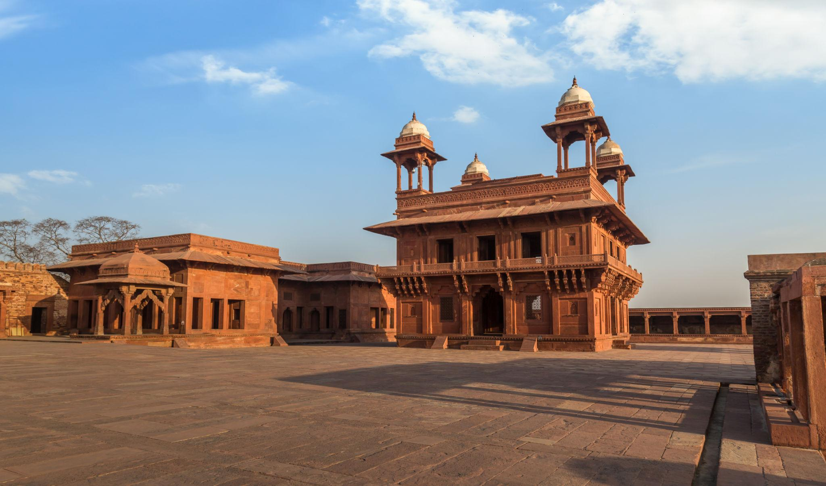
22 MAR’27 | DAY 08: | AGRA – FATEHPUR SIKRI – RANTHAMBORE (308Kms, 05Hrs drive)
Morning after breakfast drive to Ranthambore enroot visiting Fatehpur Sikri – Akbar’s Vision in Stone
Explore the magnificent fortified city of Fatehpur Sikri, an extraordinary testament to the vision and architectural ambition of Emperor Akbar. Built in 1569 to serve as the Mughal emperor’s capital, the city flourished for only a few decades before being abandoned, traditionally attributed to a severe scarcity of water. Today, its remarkably preserved palaces, courtyards and religious monuments stand as a hauntingly beautiful reminder of the grandeur of the Mughal court. Within the imposing red sandstone complex, visit the magnificent Jami Masjid, one of the finest congregational mosques of the period, and the elegant tomb of Sheikh Salim Chishti, whose pristine marble screens and delicate craftsmanship create a striking contrast with the surrounding red sandstone. Continue to the Panch Mahal, an elegant five-storeyed pavilion whose progressively diminishing levels create a graceful, almost ethereal silhouette. The Diwan-i-Khas, or Hall of Private Audiences, is particularly notable for its extraordinary central pillar and richly carved architectural details. The complex also encompasses a fascinating collection of royal palaces, courtyards and pavilions associated with the imperial household.
What makes Fatehpur Sikri particularly remarkable is the way its architecture reflects the cultural synthesis of Akbar's reign. Islamic architectural principles blend seamlessly with Hindu and Jain decorative traditions, creating a distinctive style expressed through carved brackets, columns, geometric patterns, ornamental motifs and richly sculpted details.

Continue drive to Ranthambore. Upon arrival check in at hotel in Ranthambore.

Ranthambore – Where Wilderness Meets Royal Heritage: Discover Ranthambore National Park, one of India's most celebrated tiger reserves and a captivating destination where untamed wilderness meets a remarkable royal past. Formerly the private hunting reserve of the Maharajas of Jaipur, the area became part of Project Tiger in 1972, marking an important chapter in India's efforts to protect its magnificent Bengal tiger population. Spread across approximately 410 square kilometres, the reserve occupies a dramatic landscape where the easternmost reaches of the Aravalli Hills meet the Vindhya Range. Ancient rocky outcrops, dry deciduous forests, open grasslands and tranquil lakes create an exceptional habitat for wildlife and provide a spectacular setting for exploration. Ranthambore is particularly renowned for its Bengal tigers, and visitors staying for a couple of nights have a rewarding opportunity to encounter these magnificent animals in their natural surroundings. Alongside the tiger, the park is home to a rich variety of wildlife, including leopards, sloth bears, sambar, spotted deer, wild boar, nilgai, crocodiles and numerous species of birds.

Lunch, Dinner & overnight stay at hotel in Ranthambore.

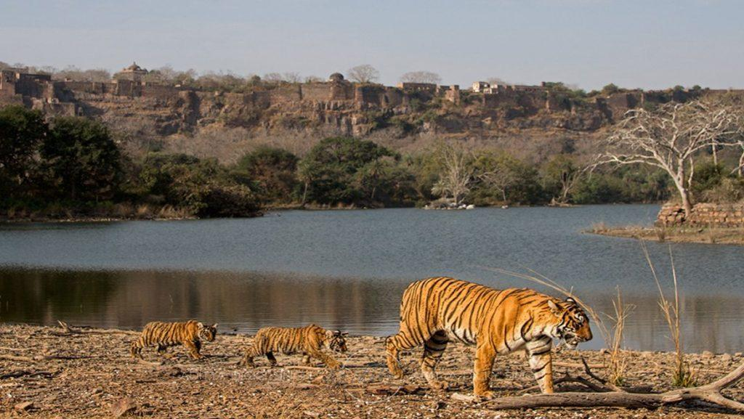
23 MAR’27 | DAY 09: | RANTHAMBORE
Enjoy morning and afternoon safari at Ranthambore national park. Ranthambore – A Rich Tapestry of Wildlife: While the Bengal tiger remains the undisputed star of Ranthambore, the reserve supports an impressive diversity of wildlife. Safari drives frequently offer opportunities to encounter large herds of chital (spotted deer) and sambar, along with sounders of wild boar, graceful nilgai antelope and the elusive chinkara gazelle moving through the open grasslands and forested terrain. The reserve is also home to sloth bears, leopards and marsh crocodiles, although sightings of these more elusive inhabitants are less predictable, adding an element of excitement to every safari. Ranthambore is equally rewarding for bird enthusiasts, with an extensive variety of resident and migratory species. Among those that may be encountered are painted and grey francolins, junglefowl, partridges, quails, crested serpent eagles, woodpeckers and flycatchers, adding colour and movement to the forest landscape. The park's lakes, ponds and seasonal waterholes attract an abundance of water birds, including storks, ducks and geese, particularly during the cooler months. Watching these birds gather around the tranquil waters, often against the backdrop of ancient ruins and rugged hills, offers a particularly memorable aspect of the Ranthambore experience.

Breakfast, Lunch Dinner & overnight stay at hotel in Ranthambore.

24 MAR’27 | DAY 10: | RANTHAMBORE – CHOWKI DHANI – JAIPUR (177Kms, 03Hrs drive)
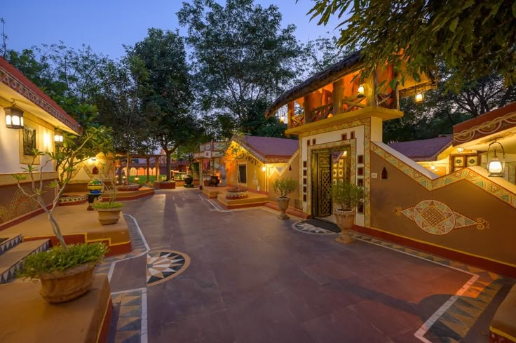
Morning after breakfast drive to Jaipur enroot visiting Chokhi Dhani – An Immersive Celebration of Rural Rajasthan: Experience the vibrant soul of Rajasthan at Chokhi Dhani, a unique cultural village that beautifully recreates the warmth, traditions and rustic charm of rural Rajasthan. Designed around traditional hut-shaped structures, the village features beautifully decorated mud walls adorned with mandala and folk art, while antique-style lamps and lanterns cast a warm, welcoming glow across the surroundings. The atmosphere comes alive with the genuine smiles of local performers, traditional music, folk dances and a fascinating array of activities that offer an engaging glimpse into Rajasthan's rich cultural heritage. A highlight of the experience is the opportunity to savour an authentic Rajasthani thali, traditionally served in an indigenous style and featuring an indulgent selection of regional delicacies. The flavours, presentation and traditional hospitality come together to create a memorable culinary experience. More than simply a restaurant or cultural attraction, Chokhi Dhani offers an immersive journey into the traditions of Rajasthan, allowing visitors to experience its colourful folklore, artistry, hospitality and cuisine in one enchanting setting.

Continue drive to Jaipur. Upon arrival check in at hotel in Jaipur.

Jaipur – The Pink City of Royal Grandeur: Founded in 1727 by Maharaja Sawai Jai Singh II, Jaipur, popularly known as the “Pink City,” is a remarkable blend of royal heritage, architectural brilliance and meticulous urban planning. Conceived as one of India's earliest planned cities, Jaipur was designed according to the principles of the ancient Shilpa Shastra, with the city divided into nine rectangular sectors, symbolically representing the nine divisions of the universe. The city's master plan was shaped by the vision of its architects, who combined traditional Hindu principles of architecture with the refined influences of Mughal and Jain design, creating a distinctive architectural identity that continues to define Jaipur today. Broad avenues, orderly streets, grand gateways and beautifully ornamented buildings reflect the extraordinary foresight behind its creation. In 1853, the city was famously painted in its characteristic terracotta-pink colour to welcome Prince Albert, who was visiting Jaipur as part of his tour of India. The colour was subsequently preserved as a symbol of hospitality and has become inseparable from the city's identity. Today, Jaipur remains a fascinating meeting point between the past and the present. Its magnificent palaces, imposing forts, bustling bazaars and historic streets continue to evoke the splendour of the Rajput era, while modern life moves energetically around them.

Dinner & overnight stay at hotel in Jaipur

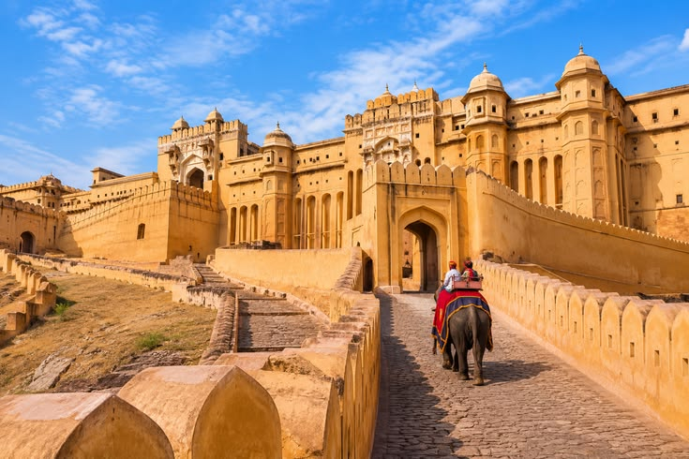
25 MAR’26 | DAY 11: | JAIPUR
Morning visit Amber Fort – A Magnificent Legacy of the Rajputs: Visit the magnificent Amber Fort, the ancient capital and stronghold of the Rajput rulers, situated approximately 11 km from Jaipur. Dramatically perched on the rugged Aravalli hills and overlooking Maota Lake, this imposing fort-palace is one of Rajasthan's finest examples of Rajput architecture, where grandeur, artistry and strategic design come together in spectacular harmony. The construction of the fort was initiated by Raja Man Singh and it remained the principal seat of the Kachwaha Rajputs until Maharaja Sawai Jai Singh II moved the capital to the newly established city of Jaipur in 1727. Explore the fort's magnificent courtyards, palaces and ceremonial spaces, including the Diwan-i-Am, or Hall of Public Audience, where the ruler received his subjects. Visit the revered Kali Temple, an important spiritual centre within the fort, before proceeding to the exquisite Jai Mandir, or Hall of Victory. The Jai Mandir is particularly renowned for its delicate inlaid panels and dazzling mirror work, which create a magical effect when illuminated. Continue to Sukh Niwas, the pleasure palace, admired for its elegant architecture and ingenious cooling system. The beautifully designed interiors and surrounding courtyards offer a glimpse into the refined lifestyle of the Rajput royalty. From the elevated terraces and ramparts of Amber Fort, enjoy breathtaking panoramic views of Maota Lake, the surrounding hills and the historic landscape below.

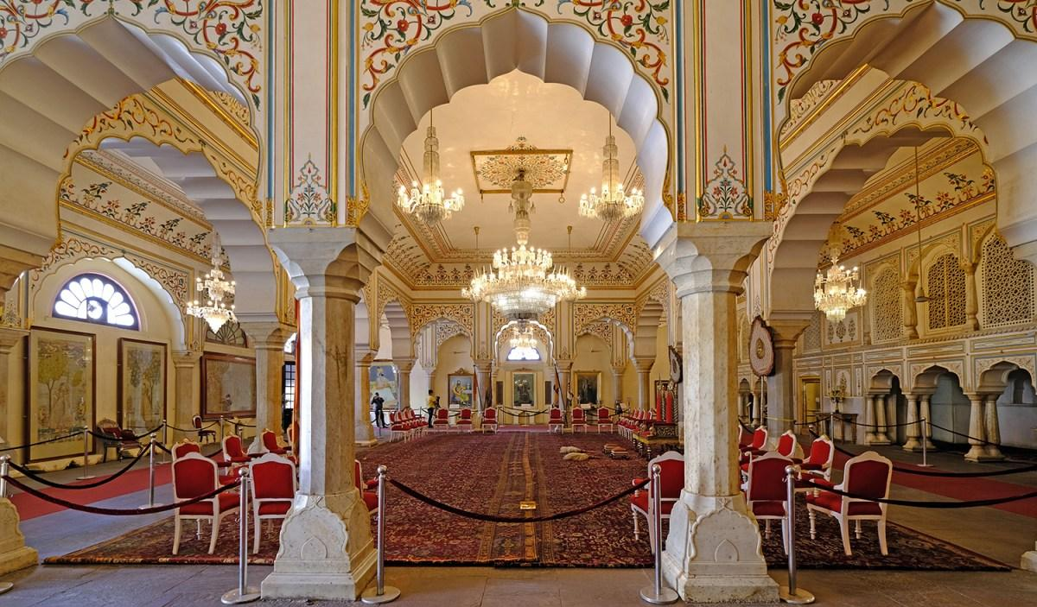
Afternoon proceed for sightseeing tour of Jaipur City Tour – Royal Heritage & Astronomical Marvels: Take a half-day tour of Jaipur, exploring its magnificent royal heritage and extraordinary architectural landmarks. Begin with a visit to the Maharaja's City Palace, an impressive complex at the heart of the walled city. Built in the 18th century, the palace occupies a significant portion of Jaipur's historic centre and continues to reflect the grandeur and refinement of the former royal court. Explore the elegant Mubarak Mahal, now home to fascinating collections of textiles, costumes and royal artefacts, as well as the museums displaying an impressive array of arms and armour. Continue through the magnificent Diwan-i-Khas and Diwan-i-Am, the private and public audience halls respectively, where the architectural details offer an evocative glimpse into the ceremonial life of the Maharajas. Continue to the remarkable Jantar Mantar, Jaipur's celebrated astronomical observatory and a UNESCO World Heritage Site. Its name is traditionally interpreted as referring to instruments used to measure celestial harmony and movements. Built by Maharaja Sawai Jai Singh II, the observatory houses a remarkable collection of monumental astronomical instruments, each designed for a specific purpose and capable of remarkably precise observations. Together, they demonstrate the extraordinary scientific knowledge and astronomical curiosity of 18th-century India. Make a photo stop at the iconic Hawa Mahal, or “Palace of the Winds,” instantly recognisable for its delicate honeycomb façade and hundreds of small windows. Built to allow royal women to observe the lively streets and processions below while remaining unseen, it has become one of Jaipur's most enduring symbols. Complete the tour with a drive through Jaipur's distinctive rose-pink residential and commercial quarters, where historic façades, bustling bazaars and everyday city life combine to create the unmistakable character of the Pink City.

Dinner & overnight stay at hotel in Jaipur

26 MAR’27 | DAY 12: | JAIPUR – CHITTORGARH – UDAIPUR (424Kms, 07Hrs drive)
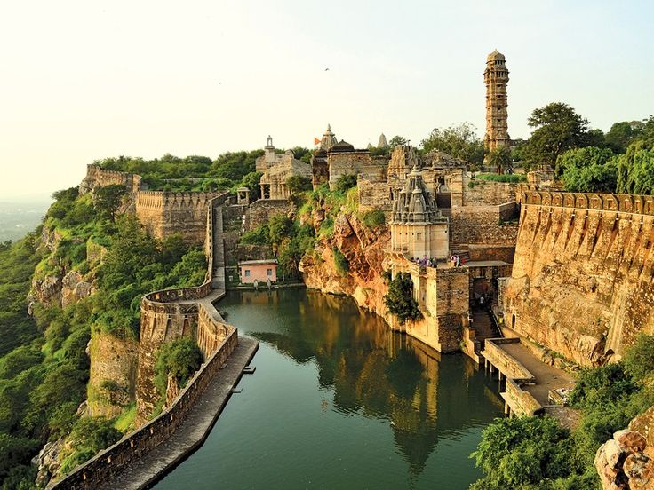
Morning after breakfast proceed for Udaipur enroot visiting Chittorgarh Fort – A Monument to Rajput Valour & Glory: Visit the magnificent Chittorgarh Fort, one of Rajasthan's most imposing historic landmarks and an enduring symbol of Rajput courage, sacrifice and pride. Rising dramatically above the surrounding landscape, this vast fortified complex preserves the remnants of a once-powerful Rajput capital, where legends of valour and heroic resistance have been woven into the history of Mewar. According to tradition, the origins of the fort are associated with Bhim, one of the Pandavas of the Mahabharata. Although the ancient city within the fort now lies largely deserted, its impressive palaces, temples, towers and gateways continue to evoke the grandeur of its illustrious past. Explore the remains of Rana Kumbha's Palace, once one of the most important royal residences within the fort, and visit Fateh Prakash Palace, which reflects the later architectural heritage of Mewar. One of the most spectacular landmarks is the 37-metre-high Jaya Stambh, or Tower of Victory, commissioned by Rana Kumbha to commemorate his victory over the forces of the Sultan of Malwa in the 15th century. Rising majestically above the fort, the tower is richly decorated with intricate carvings depicting Hindu deities, warriors and scenes from mythology. Also admire the 22-metre-high Kirti Stambh, or Tower of Fame, an elegant Jain monument dedicated to Adinath, the first Jain Tirthankara. Its seven-storeyed structure is richly ornamented with sculptures representing Jain Tirthankaras and other sacred figures, reflecting the religious diversity and artistic sophistication of medieval Mewar. Beyond its architectural splendour, Chittorgarh carries a powerful sense of history. Its massive ramparts, ruined palaces and soaring victory towers stand as enduring reminders of a kingdom that repeatedly defended its independence against formidable adversaries.

Continue drive to Udaipur. Upon arrival check in at hotel in Udaipur.
Udaipur – The Romantic Soul of Rajasthan: Nestled amidst the undulating Aravalli Hills of southern Rajasthan, Udaipur is one of India's most enchanting cities and is widely regarded as one of the country's most romantic destinations. With its shimmering lakes, magnificent marble palaces, beautifully landscaped gardens and lush green hills, the city presents a picture of timeless elegance and has earned the evocative title of “Venice of the East.” Founded by Maharana Udai Singh II in 1568, Udaipur was conceived as a traditionally planned and fortified city, with imposing palaces, ornate temples, elegant havelis and defensive structures woven into its landscape. The city's architecture reflects the grandeur and sophistication of the Mewar dynasty, while its lakes and surrounding hills lend it an unmistakable sense of tranquillity.

Rest of the day free for relaxation / explore surrounding.

Dinner and overnight stay at hotel in Udaipur

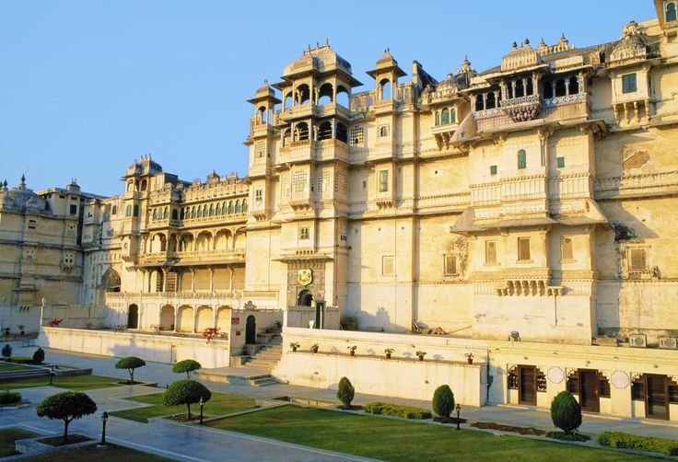
27 MAR’27 | DAY 13: | UDAIPUR
Morning after breakfast proceed for sightseeing tour of Udaipur City Tour – Palaces, Temples & Artistic Heritage: Begin your half-day sightseeing tour of Udaipur with a visit to the magnificent City Palace and Museum, an extraordinary complex rising majestically above the shores of Lake Pichola. Considered one of the largest palace complexes in India, it represents a harmonious fusion of Rajput architectural traditions and Mughal influences. Explore its ornate courtyards, grand halls, balconies and richly decorated chambers, while the museum offers fascinating insights into the splendour and lifestyle of the former Mewar rulers.
Continue to the beautiful Jagdish Temple, an impressive 17th-century Hindu temple dedicated to Lord Vishnu. Its towering structure and intricate stone carvings make it one of Udaipur's most significant religious and architectural landmarks. Take a scenic drive around Fateh Sagar Lake, one of Udaipur's most picturesque lakes, framed by the Aravalli Hills and surrounded by a tranquil landscape. The drive offers wonderful views of the water and the city's elegant lakeside setting. Visit Saheliyon-ki-Bari, meaning the “Garden of the Maids of Honour,” a graceful ornamental garden created as a retreat for the royal ladies. Beautiful fountains, marble kiosks, lotus pools, manicured lawns and shady walkways create an atmosphere of serenity and refinement, offering a glimpse into the leisure and elegance of the Mewar court. Conclude the sightseeing with a visit to the Bharatiya Lok Kala Mandal, also known as the Folk Art Museum, where an engaging collection of traditional Rajasthani folk art, costumes, puppets, masks, musical instruments and decorative crafts celebrates the vibrant cultural traditions of the region.

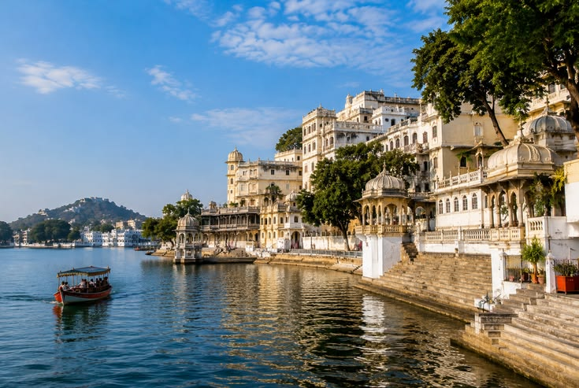
Afternoon enjoy boat ride at Lake Pichola & Jag Mandir – Udaipur’s Timeless Lakeside Beauty: Enjoy a leisurely boat ride on the enchanting Lake Pichola, one of Udaipur's most iconic and picturesque landmarks. Stretching approximately 4 km in length and 3 km in width, the lake is surrounded by the dramatic Aravalli Hills and beautifully framed by magnificent palaces, historic havelis, ancient temples, ghats and elegant embankments. As the boat glides across the tranquil waters, enjoy spectacular panoramic views of Udaipur's architectural treasures reflected against the shimmering surface of the lake. The changing light of the day lends an especially magical character to the landscape, with the palaces and surrounding hills taking on warm golden hues around sunset. Continue to Jag Mandir, a graceful island palace rising from the waters of Lake Pichola. Explore its elegant courtyards, marble structures and beautifully landscaped surroundings, including the exquisite Gul Mahal Pavilion, admired for its refined architecture and historical significance.
The experience offers a wonderful opportunity to appreciate Udaipur from a different perspective, where water, architecture, nature and royal heritage come together in perfect harmony.

Dinner and overnight stay at hotel in Udaipur

28 MAR’27 | DAY 14: | UDAIPUR – RANAKPUR – JODHPUR (262Kms, 05Hrs drive)
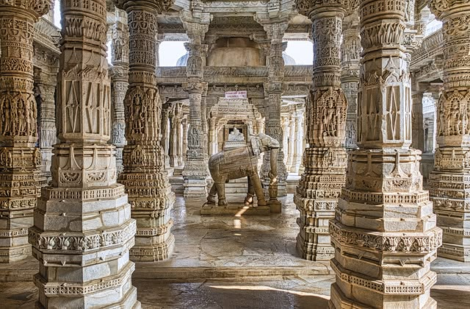
Continue drive to Jodhpur. Upon arrival check in at hotel in Jodhpur. Jodhpur – The Blue City at the Gateway to the Thar: Standing proudly at the threshold of the Thar Desert, Jodhpur is the second-largest city in Rajasthan and the historic heart of the Marwar region. Founded in 1459 by Rao Jodha, the city grew into an important centre of Rajput power and commerce, its remarkable heritage still visible throughout its historic streets and monumental architecture. The old city is enclosed by an impressive 10-kilometre-long defensive wall, with ancient gateways leading into a maze of narrow lanes, bustling bazaars and traditional houses. Dominating the city from its dramatic rocky hilltop is the magnificent Mehrangarh Fort, one of Rajasthan's most spectacular fortresses. Its massive ramparts rise above the blue-painted houses below, while the exquisite red-sandstone palaces within form an extraordinary architectural ensemble of courtyards, balconies and richly ornamented interiors.

Dinner and overnight stay at hotel in Jodhpur

29 MAR’27 | DAY 15: | JODHPUR – POKHARAN – JAISALMER (288Kms, 04Hrs drive)
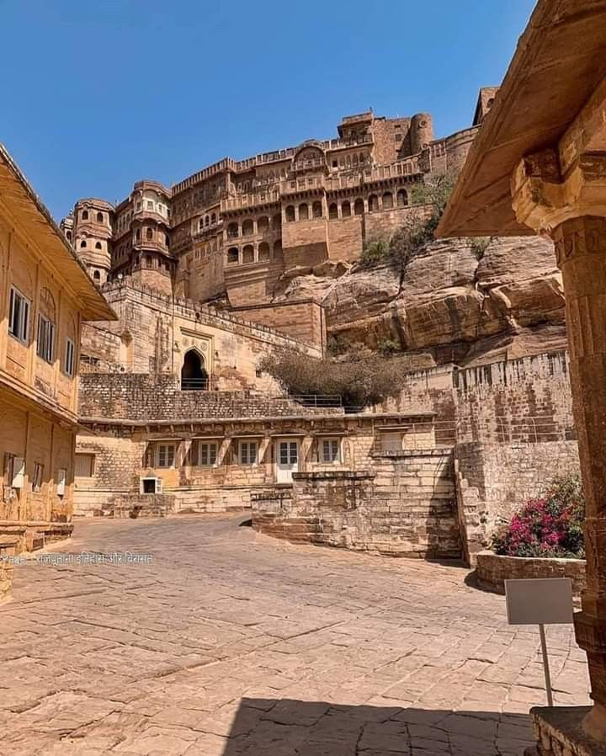
Morning after breakfast proceed for Jodhpur City Tour – Forts, Royal Treasures & Architectural Elegance: Begin your half-day sightseeing tour with a visit to the magnificent Mehrangarh Fort, dramatically positioned atop a low sandstone hill overlooking the Blue City. One of Rajasthan's most impressive fortresses, its imposing ramparts enclose a remarkable collection of royal palaces, courtyards and richly decorated chambers. Explore the exquisite palace apartments, including the Sukh Mahal, Phool Mahal and Sheesh Mahal, each offering a fascinating glimpse into the refined lifestyle of the erstwhile Marwar royalty. Their ornate interiors are complemented by an exceptional collection of jewellery, royal costumes, armour, palanquins, howdahs and other historic artefacts, preserving the splendour and traditions of the Rathore dynasty. Continue to the elegant Jaswant Thada, a beautifully crafted white-marble memorial built in 1899 in honour of Maharaja Jaswant Singh II. Set amidst tranquil surroundings, the memorial is adorned with delicate marble latticework and fine architectural details. It subsequently became the royal cremation ground, with several additional cenotaphs constructed here in memory of members of the royal family. Later, visit the museum at Umaid Bhawan Palace, one of India's grandest palace residences and an architectural landmark of 20th-century Jodhpur. The museum presents an engaging collection of royal memorabilia, vintage photographs, clocks, furniture, decorative arts and other artefacts, offering an insight into the lifestyle and legacy of the Jodhpur royal family.

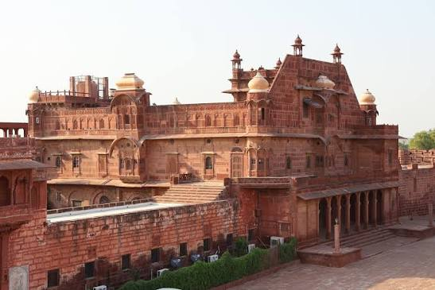
After sightseeing drive to Jaisalmer enroot visting Pokhran Fort, also known as Balagarh Fort, a distinguished Rajput stronghold rising amidst the stark and captivating landscapes of the Thar Desert. Built in the 14th century by Rao Maldeo, the fort is an impressive example of traditional Rajput architecture, characterised by its imposing sandstone walls, fortified gateways and finely carved architectural details. Constructed as both a fortress and royal residence, Pokhran Fort reflects the remarkable ability of Rajput architects to combine military strength with the elegance and comforts of royal living. Its architecture was thoughtfully adapted to the demanding desert environment, with carefully planned courtyards, shaded spaces and thick sandstone walls providing protection from the harsh climate.

Continue drive to Jaisalmer. Upon arrival check in at hotel in Jaisalmer.
Jaisalmer – The Golden City of the Thar: Rising majestically from the heart of the Thar Desert, the captivating city of Jaisalmer was founded in 1156 AD by Prince Jaisal, a Rajput ruler of the Bhati dynasty. Built almost entirely from warm yellow sandstone, the city takes on a magical golden hue at sunset, earning it the evocative title of the “Golden City.” Dominating the desert horizon is the magnificent Jaisalmer Fort, with its imposing crenellated walls and labyrinth of narrow lanes leading through a living medieval city. Within and around the fort, exquisitely carved sandstone havelis, ornate façades, temples and traditional residences reveal the extraordinary craftsmanship of the local artisans.

Rest of the day free for relaxation / explore surrounding.

Dinner and overnight stay at hotel in Jaisalmer

30 MAR’27 | DAY 16: | JAISALMER (288Kms, 04Hrs drive)
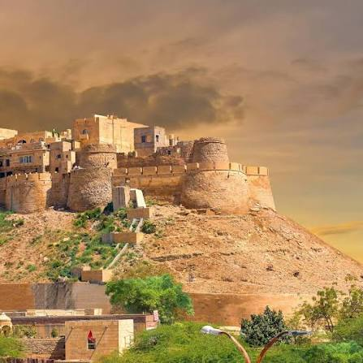
Morning after breakfast proceed Jaisalmer Sightseeing – A Golden Journey Through the Thar: Throbbing at the heart of the Thar Desert, Jaisalmer is an extraordinary sandstone wonderland where medieval architecture, desert heritage and living traditions come together. Take a half-day sightseeing tour through this “Golden City”, discovering its magnificent fort, ancient temples and exquisitely carved merchant mansions. Begin with the magnificent Jaisalmer Fort, rising dramatically atop the approximately 80-metre-high Trikuta Hill. Built by Rawal Jaisal, the fort is remarkable for being a living heritage site, with a significant part of Jaisalmer's population still residing within its ancient walls. Its golden sandstone ramparts, narrow lanes, traditional homes and bustling atmosphere create an extraordinary sense of stepping into a medieval desert city. Within the fort, discover a remarkable group of Jain temples dating from the 12th to 15th centuries, celebrated for their intricate sandstone carvings, sculpted pillars and finely detailed architectural ornamentation. These temples are among the finest expressions of the artistic and spiritual heritage that flourished along Jaisalmer's historic trade routes. Continue to Badal Vilas Palace, an elegant 20th-century palace associated with the former rulers of Jaisalmer. Its distinctive architecture and finely worked sandstone provide another fascinating glimpse into the city's more recent royal heritage. Jaisalmer is equally renowned for its magnificent merchant havelis, built by wealthy traders whose fortunes grew through the thriving desert trade routes. Visit Patwon Ki Haveli, an impressive five-storey mansion complex dating from the early 19th century, renowned for its beautifully carved pillars, balconies, façades and intricate murals.
Also admire Salim Singh Ki Haveli, distinguished by its distinctive architecture and ornate upper storeys, and Nathmalji Ki Haveli, celebrated for its elaborate carvings and remarkable craftsmanship. Together, these mansions reveal the extraordinary skill and imagination of Jaisalmer's master stone craftsmen. As the golden sandstone catches the changing light of the desert sun, the city seems to glow from within, creating an atmosphere that is both timeless and captivating.
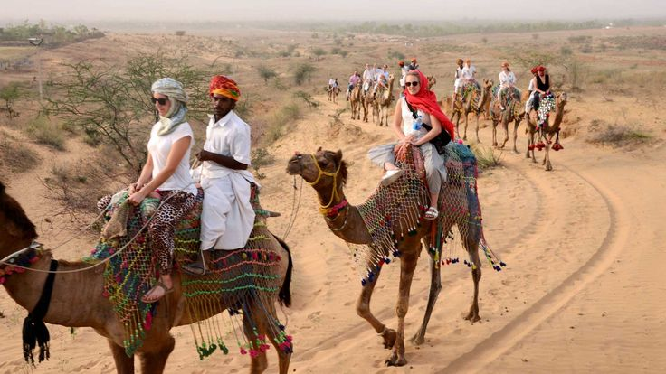
Afternoon proceed for Osian – An Ancient Oasis of Temple Art & Desert Heritage: Rising gracefully from the golden sands of the Thar Desert, the ancient town of Osian was once an important trading centre between the 8th and 12th centuries, flourishing along the historic caravan routes that connected Rajasthan with distant lands. A visit to Osian is beautifully complemented by a camel safari at sunset. As the sun descends over the endless dunes, casting a warm golden glow across the desert, the slow rhythmic journey by camel offers an evocative and unforgettable experience of Rajasthan’s timeless desert charm.

Dinner and overnight stay at hotel in Jaisalmer

31 MAR’27 | DAY 17: | JAISALMER – BIKANER (330Kms, 05Hrs drive)
Morning after breakfast drive to Bikaner. Upon arrival check in at hotel in Bikaner.
Bikaner – A Desert Legacy of Forts, Havelis & Camels: Set amidst the golden landscapes of northern Rajasthan, Bikaner was founded in 1488 by Rao Bika, son of Rao Jodha, the illustrious founder of Jodhpur. Strategically positioned along the historic caravan routes crossing the Thar Desert, the city grew into an important staging post for traders and travellers journeying between the great desert kingdoms and distant markets. Like many historic cities of Rajasthan, Bikaner’s old quarter is enclosed within impressive crenellated walls, preserving an atmosphere of a bygone era. Wandering through its narrow lanes reveals a captivating ensemble of exquisitely carved merchant havelis, ancient temples and colourful bazaars, where centuries-old traditions continue to lend the city its distinctive medieval character.

Evening enjoy visit to local bazaar / explore surrounding.

Dinner and overnight stay at hotel in Bikaner

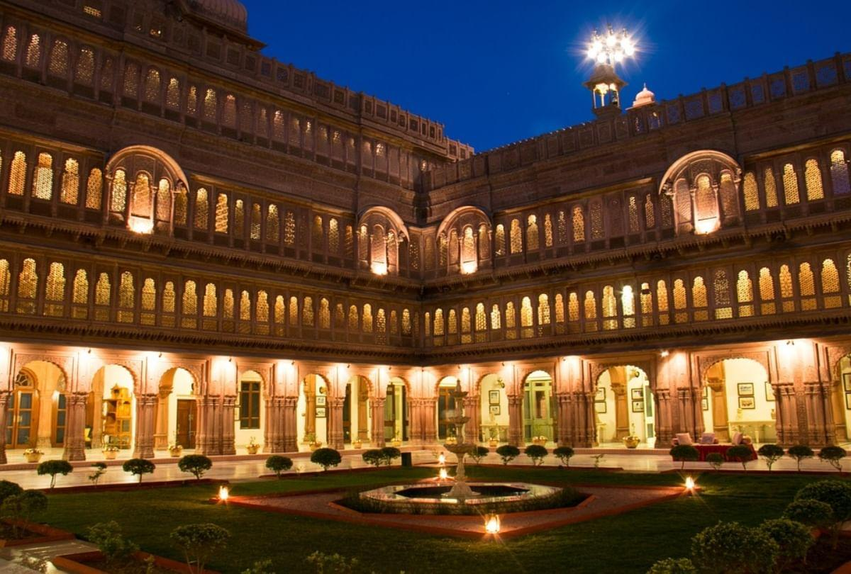
01 APR’27 | DAY 18: | BIKANER – DELHI (SSAH DURONT – 12:10Hrs / 19:30Hrs) – DEPART DELHI
Morning after breakfast proceed for sightseeing tour of Bikaner visiting Junagarh Fort – A Masterpiece of Bikaner’s Royal Heritage: The magnificent Junagarh Fort, completed in 1593, is among Rajasthan’s finest examples of royal architecture, distinguished by its imposing structure, exquisite stone carving and lavishly ornamented interiors. Unlike many of Rajasthan’s great hilltop forts, Junagarh rises majestically from the plains, enclosing within its formidable walls a remarkable succession of palaces, courtyards and royal chambers. Step inside to discover interiors of extraordinary artistry, adorned with delicate shell work, mirror and glass inlays, gilded ornamentation, lacquer work, richly carved marble and intricate decorative details. Each palace and chamber reflects the refined taste and grandeur of Bikaner’s former rulers. Among the principal highlights are the Diwan-i-Khas, the royal hall of private audience; Phool Mahal, celebrated for its delicate ornamentation; and Chandra Mahal, distinguished by its marble work, mirror decoration and intricate carvings. Anup Mahal, once the splendid coronation hall, showcases some of the fort’s most elaborate craftsmanship, while Gaj Mandir, with its dazzling mirrored Shish Mahal, offers a particularly enchanting glimpse into the opulence of royal life. The Har Mandir, the royal temple, adds a spiritual dimension to the magnificent complex. The fort also houses a fascinating museum, where an impressive collection of manuscripts, weapons, jewellery, royal costumes and other artefacts provides further insight into the history, culture and ceremonial traditions of the Bikaner court.

After sightseeing drive to Bikaner railway station to board train for Delhi. Meeting and assistance upon arrival at Delhi railways station and drive to international airport to board flight for onward destination.

END OF THE SERVICES

TOUR COST:
CATEGORY | COST PER PERSON
Towards the cost for North India tour | Euro 1627 per person
Single Room Supplement | USD 541 per Single

CiTY | HOTEL 4 STAR | LINKS | NIGHTS
Delhi | Park Inn By Radisson IP Extension or similar | Park Inn By Radisson IP Extension | 02 Night
Varanasi | Hotel Tridev or similar | Hotel Tridev Varanasi | 02 Night
Khajuraho | Ramada By Wyndham or similar | Ramada By Wyndham | 01 Night
Orchha | Orchha Palace or similar | Orchha Palace | 01 Night
Agra | Grand Mercure or similar | Grand Mercure | 01 Night
Ranthambore | Sterling Bagh or similar | Sterling Bagh Ranthambore | 02 Night
Jaipur | Sunday Hotel or similar | Sunday Hotel | 02 Night
Udaipur | Justa Rajputana Resort or similar | Justa Rajputana Resort | 02 Night
Jodhpur | Vega by Ozone or similar | Vega By Ozone | 01 Night
Jaisalmer | Sterling Rudraksh or similar | Sterling Rudraksh | 02 Night
Bikaner | Chandra Raj Mahal or similar | Chandra Raj Mahal | 01 Night
Total, number of nights |  |  | 17 Nights

Air:
Date | Sector | Flight | Departure | Arrival | Fare
17 Mar’27 | Delhi – Varanasi | 6E 2361 | 12:55Hrs | 14:20Hrs | Euro 129 per person

*******Air Fare are subject to change without notice*******

Our prices include:

Accomodation based on Double room.

Half Board basis as per program (Breakfast, Dinner) and full board in Ranthambore (Breakfast, Lunch, Dinner)

All arrival/departure transfer, sightseeing tour excursions by Air-conditioned Tempo Traveller.

Entrance fees to Monuments

Italian speaking guide as per program

Morning and afternoon safari by canter at Ranthambore

Aarti ceremony in Varanasi

Early Morning boat ride in Varanasi

Elephant ride at Amer Fort in Jaipur

Boat ride at Lake Pichola in Udaipur

Camel ride in Jaisalmer

Camel breeding farm visit in Bikaner

Train tickets for travel sector Varanasi to Khajuraho by Vande Bharat Express in Air-Conditioned Chair car

Train tickets for travel sector Jhansi to Agra by Vande Bharat Express in Air-Conditioned Chair car

Train tickets for travel sector Bikaner to Delhi by Sdah Duronto in Three Tier Air-Conditioned

02 night in Delhi with breakfast and Dinner basis.

02 night in Varanasi with breakfast and Dinner basis.

01 night in Khajuraho with breakfast and Dinner basis.

01 night in Orchha with breakfast and Dinner basis.

01 night in Agra with breakfast and Dinner basis.

02 night in Ranthambore with full board basis (Breakfast, Lunch, Dinner).

02 night in Jaipur with breakfast and Dinner basis.

02 night in Udaipur with breakfast and Dinner basis.

01 night in Jodhpur with breakfast and Dinner basis.

02 night in Jaisalmer with breakfast and Dinner basis.

01 night in Bikaner with breakfast and Dinner basis.

Government tax.

Our prices do not include:

Air fare

Entry visa.

Visas can be obtained online at: www.indianvisaonline.gov.in

Tips for guides (at the client's discretion).

Travel and cancellation insurance (optional).

Beverages.

Any services not mentioned as included, including personal extras such as telephone calls, laundry

service, etc.

